Project Design Phase-II
Data Flow Diagram & User Stories
Date | 30 September 2026
Team ID | SWTID-2026-1259
Project Name | Streamlining IT Procurement: Automating Standard Laptop Orders with Flow Designer
Maximum Marks | 4 Marks

Data Flow Diagrams:
A Data Flow Diagram (DFD) is a traditional visual representation of the information flows within a system. A neat and clear DFD can depict the right amount of the system requirement graphically. It shows how data enters and leaves the system, what changes the information, and where data is stored.
Project DFD (Level 0): Streamlining IT Procurement – Automating Standard Laptop Orders with Flow Designer
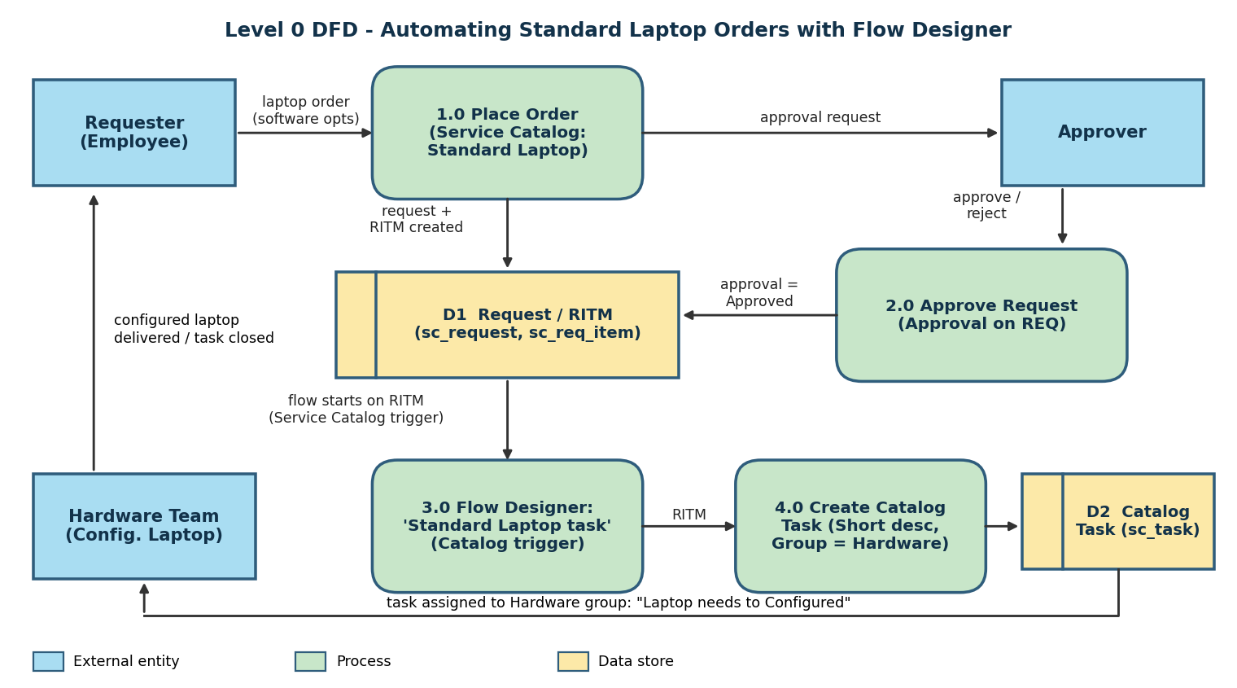
Flow
- The requester opens the Service Catalog, selects Standard Laptop under Hardware and places the order.
- A Request (REQ) and Requested Item (RITM) are created and an approval is sent to the approver.
- The approver approves the request.
- The 'Standard Laptop task' flow (attached to the catalog item) is triggered by the Service Catalog trigger.
- The 'Create Catalog Task' action creates a catalog task with short description 'Laptop needs to Configured' and Assignment group 'Hardware'.
- The Hardware team receives the task, configures the laptop and closes the task.

User Stories
Use the below template to list all the user stories for the product.
User Type | Functional Requirement (Epic) | User Story Number | User Story / Task | Acceptance criteria | Priority | Release
Requester (Employee) | Order Standard Laptop | USN-1 | As a requester, I can open the Service Catalog, go to Hardware and select the Standard Laptop item so that I can raise a laptop request. | I can see the Standard Laptop item (Lenovo Carbon x1) with its specs and price | High | Sprint-1
 |  | USN-2 | As a requester, I can choose optional software (Adobe Acrobat / Photoshop), add additional software requirements and click Order Now to place the request. | Order Status page shows 'Your request has been submitted' with a Request Number (REQ) | High | Sprint-1
 | Track Request | USN-3 | As a requester, I can open my Request Number and view the Requested Item and its catalog tasks so that I can track the progress of my laptop. | I can see the RITM and the linked Catalog Task with its current state | Medium | Sprint-2
Approver | Approval | USN-4 | As an approver, I can view the pending approval under the Approvers section of the request. | Approval record is shown in 'Requested' state with the approver name | High | Sprint-1
 |  | USN-5 | As an approver, I can approve or reject the laptop request so that procurement can proceed. | Approval state changes to 'Approved' (or 'Rejected') and the request moves ahead | High | Sprint-1
Administrator | Create Flow | USN-6 | As an administrator, I can create a flow named 'Standard Laptop task' in Flow Designer (Application: Global, Run As: System User) so that laptop tasks can be automated. | Flow is created and saved with the correct name, application and run-as user | High | Sprint-1
 |  | USN-7 | As an administrator, I can add the Service Catalog trigger and the 'Create Catalog Task' action (short description 'Laptop needs to Configured', Assignment group 'Hardware', Approval 'Approved') so that a task is generated automatically. | Flow shows the trigger and action; flow status is Active after activation | High | Sprint-1
 | Flow Assignment | USN-8 | As an administrator, I can attach the 'Standard Laptop task' flow to the Standard Laptop catalog item under Maintain Items > Process Engine so that it runs for every order. | Catalog item shows the flow in the Process Engine tab and the record is saved | High | Sprint-2
Hardware Team Member | Task Assignment | USN-9 | As a hardware team member, I receive a catalog task (SCTASK) automatically assigned to the Hardware group when a standard laptop is ordered. | Catalog task exists under the Requested Item with Assignment group = Hardware | High | Sprint-2
 | Laptop Configuration | USN-10 | As a hardware team member, I can open the catalog task, work on it and close it after configuring the laptop so that it is ready on arrival. | Task can be updated and closed; configured laptop is ready for the user | Medium | Sprint-3
IT Procurement Team Member | Process Automation | USN-11 | As an IT procurement team member, I want tasks to be generated and assigned to the hardware team automatically so that manual intervention and errors are reduced. | No manual task creation needed; task appears within the order lifecycle | High | Sprint-2

